Book

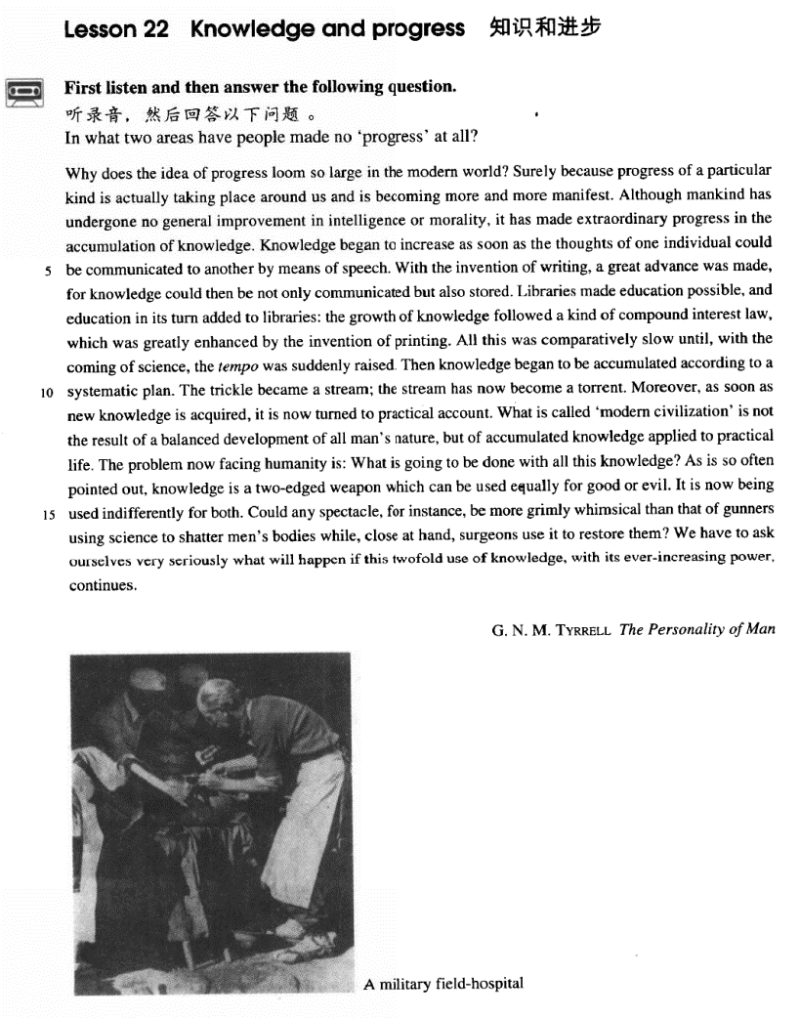

课文

Why does the idea of progress loom so large in the modern world?

为什么进步这个概念在现代世界显得如此突出？

Surely because progress of a particular kind is actually taking place around us and is becoming more and more manifest.

无疑是因为有一种特殊的进步实际上正在我们周围发生，而且变得越来越明显。

Although mankind has undergone no general improvement in intelligence or morality, it has made extraordinary progress in the accumulation of knowledge.

虽然人类有智力和道德上没有得到普遍提高，但在知识积累方面却取得了巨大的进步。

Knowledge began to increase as soon as the thoughts of one individual could be communicated to another by means of speech.

人一旦能用语言同别人交流思想，知识的积累便开始了。

With the invention of writing, a great advance was made, for knowledge could then be not only communicated but also stored.

随着书写的发明，又迈进了一大步，因为这样一来，知识不仅能交流，而且能储存了。

Libraries made education possible, and education in its turn added to libraries: the growth of knowledge followed a kind of compound interest law, which was greatly enhanced by the invention of printing.

藏书使教育成为可能，而教育反过来又丰富了藏书，因为知识的增长遵循着一种“滚雪球”的规律，印刷术的发明又大大提高了知识增长的速度。

All this was comparatively slow until, with the coming of science, the tempo was suddenly raised.

所有这些发展都比较缓慢，而随着科学的到来，增长的速度才突然加快。

Then knowledge began to be accumulated according to a systematic plan.

于是，知识便开始有系统有计划地积累起来。

The trickle became a stream: the stream has now become a torrent.

涓涓细流汇成小溪，小溪现已变成了奔腾的江河。

Moreover, as soon as new knowledge is acquired, it is now turned to practical account.

而且，新知识一旦获得，便得到实际应用。

What is called 'modern civilization' is not the result of a balanced development of all man's nature, but of accumulated knowledge applied to practical life.

所谓“现代文明”并不是人的天性平衡发展的结果，而是积累起来的知识应用到实际生活中的结果。

The problem now facing humanity is: What is going to be done with all this knowledge?

现在人类面临的问题是：用这些知识去做什么？

As is so often pointed out, knowledge is a two-edged weapon which can be used equally for good or evil.

正像人们常常指出的，知识是一把双刃刀，可以用于造福，也可以用来为害。

It is now being used indifferently for both.

人们现在正漫不经心地把知识用于这两个方面，

Could any spectacle, for instance, be more grimly whimsical than that of gunners using science to shatter men's bodies while, close at hand, surgeons use it to restore them?

例如：炮兵利用科学毁坏人的身体、而外科医生就在附近用科学抢救被炮兵毁坏的人体，还有什么情景比这更可怕、更怪诞的吗？

We have to ask ourselves very seriously what will happen if this twofold use of knowledge, with its ever-increasing power, continues.

我们不得不严肃地问问我们自己：随着日益增长的知识的力量，如果我们继续利用知识的这种双重性，将会发生什么样的情况呢？

词汇讲解

### manifest

* **manifest** ['mænɪfest] adj. 明显的

**manifest** adj. **clear**; **obvious**

**manifest** vt. 使……显露出来

* Musical talent usually manifests itself in childhood.
* The fact of first-rate importance is the predominant role that custom plays in experience and in belief, and the very great varieties it may **manifest**.

**【辨析】**

**explicit** adj.（语言表达）清晰的，明确的；直言的；坦率的

* **explicit** instructions
* Possible side effects should be made **explicit**.
* a sexually **explicit** （派生；暴露的、露骨的）movie

**implicit** adj.含蓄的；不直接言明的

* an **implicit** criticism of government policy

### morality

* **morality** [mə'ræləti] n. 道德
* public **morality**
* enhance people’s consciousness of public **morality**

**【同根词】**

**moral** adj. 道德的；道义的

**morals** n. 道德标准

* the morals and **customs** of the Victorian period

**【近义词】**

**ethics** n. 职业道德

* medical / commercial / journalistic **ethics**

**【扩展】**

**values** n. 价值观

* traditional / conservative / liberal **values**

### compound

* **compound** ['kɒmpaʊnd] adj. 复合的

**compound** adj. 复合的

* a **compound** noun / adjective / sentence
* **compound** interest 复利
* simple interest 单利

**compound** n. 化合物；复合词

**be compounded of / from…** 由…组成

* The DNA molecule **is compounded of / from** many smaller molecules.

### indifferently

* **indifferently** [ɪn'dɪfrəntlɪ] adv. 冷漠地，不在乎地

**be indifferent to …** 对…漠不关心

* How can you **be indifferent to** the sufferings of the refugees?

**【近义词组】**表达“**对…漠不关心、无动于衷**”：

**be apathetic about …**

**be unsympathetic to …**

* **口语表达**：“不在乎”：
* It makes no difference to me.
* I don’t mind / care.
* It’s all the same to me.
* **口语表达**：“在乎”：
* It makes a lot of / a whole world’s difference to me.
* It matters to me.
* **It** means a lot to me.
* It weighs heavily with me.

### whimsical

* **whimsical** ['wɪmzɪkl] adj. 稀奇古怪的，异想天开的

**【同根词】**

whimsy n.怪念头；古怪可笑的举动；吊儿郎当；随心所欲

* one of her bizarre **whimsies**

**whim** n. 心血来潮；一时的兴致；突发的奇想

**on a whim** 心血来潮做某事

* We bought the house **on a whim**.

**at the whim of sb.** 由于某人一时冲动

* I always been afraid to go up in an airplane. Now I'm gonna jump out of one **at the whim of a maniac**!

### shatter

* **shatter** ['ʃætə(r)] v. 粉碎

**shatter** v. **英文解释：** to break something suddenly into pieces 突然把某物打成粉碎

* One of his knees was **shattered** by a bullet.

**shatter one’s** hopes / illusions / confidence 粉碎了某人的…

**shatter** the peace / silence 打破…

**【近义词】**

**smash**

* **smash**-and-grab
* **smash** a window / glass 打碎…
* **smash** （粉碎）terrorism
* **smash** （粉碎，比喻义）the Gang of Four

**crush**

* **crush** the rebellion / uprising

课文讲解

# （第一段）

# Why does the idea of progress loom so large in the modern world?

知识点（1）

**loom large** 令人忧虑，令人惊恐（并似乎难以避免）

* Human right issues will continue to **loom large** in China-U.S. relations.
* The adverse effects of the Great Leap Forward and of the Cultural Revolution still **loom large** in the minds of Chinese policy makers.

知识点（2）Lesson04-02

**写作题材：**Question-Answer Pattern 问题回答模式，给出设问句，自问自答

**question (why …)**

**answer (because …)**

**supportive sentences**

* **Why**, you may wonder, should spiders be our friends? **Because** they destroy so many insects, and insects include some of the greatest enemies of the human race. …

# Surely because progress of a particular kind is actually taking place around us and is becoming more and more manifest.

**语法分析：**

Surely because progress *of a particular kin**d（介词短语当后置定语）* is actually taking place around us and is becoming more and more manifest.

知识点（1）Lesson03-34、Lesson 03-40、Lesson 03-41

**语法：**如果把表示类型的词放在前面，如**sort**、**kind**、**type**，后面的可数名词可以当**不可数名词**；如果把表示类型的词放在后面，可数名词放在前面时一般用**复数**

* a new kind **of** **machine**
* **machines** **of** a new kind
* Students specialize in **a** particular **type of** practical joke: the hoax.
* practical **jokes** of a particular **type**
* a particular **kind** of **progress**（单数）
* The more expensive **kind of antique shop**（单数） where rare objects are beautifully displayed in glass cases to keep them free from dust **is**（单数） usually a forbidding place.
* Antique **shops**（复数） of the more expensive kind where rare objects are beautifully displayed in glass cases to keep them free from dust**are（**复数） usually forbidding places.

**【复习】**Lesson03-12、Lesson 03-14、Lesson 03-42、Lesson 03-54

**a sort of**= **a kind of …** 1.一种、某种…；2.像…一样；有些像……的；……般的 ；

* We sometimes imagine a desert island to be **a sort of**（第2种含义）paradise where the sun always shines.
* In spite of this, the Italians regarded him as **a sort of**（第2种含义）hero.
* Libraries made education possible, and education in its turn added to libraries: the growth of knowledge followed **a kind of**compound interest law, which was greatly enhanced by the invention of printing.
* Since its discovery, it has become **a sort of**（第2种含义） potholers' Everest.
* They were visited by a large colony of ants which obtained **a sort of** （第2种含义）honey from them
* An atom is **a kind of**（第2种含义） solar system.

知识点（2）

**be becoming more and more / increasingly + adj.** 变得越来越…

* So great is our passion for doing things for ourselves, that we **are becoming increasingly less dependent** on specialized labour.
* As a result of all these factors, governments **are becoming increasingly dependent** on biologists and social scientists for planning the appropriate programs and putting them into effect.

# Although mankind has undergone no general improvement in intelligence or morality, it has made extraordinary progress in the accumulation of knowledge.

**语法分析：**

Although mankind has undergone no general improvement in intelligence or morality（让步状语从句）, it（对应mankind） has made extraordinary progress in the accumulation of knowledge.

知识点（1）

**【近义词组】**表达“**经历**”：

**undergo** (underwent, undergone) 经历（强调主语本身在变化）

**experience**

**go through**

**know**

**see**

**witness**

* **强调本身变化：**
* **undergo** surgery
* Mankind has **undergone** no general improvement.
* The bridge has **undergone** a series of modifications.
* **不强调本身变化：**
* experience difficulties
* go through a crisis
* He has **seen** / **known** so much misery.
* The 1980s **witnessed** enormous growth in the economy.

知识点（2）

**【近义词组】**表达“**取得进步**”：

**make (an) improvement / improvements in …**

**make progress in ...**

**make an advance / advances in…**

**【修饰语】**

**great**, **enormous**, **considerable**, **extraordinary**, **substantial** …

知识点（3）

**man 后面代词对应 he**

**mankind / the human race 后面代词对应 it**

* **Man** **has** his problems.
* **Mankind** / **The human race** has **its** problems.
* It comes nearer to the engines with which **man** has 'conquered' the air, as **he** boasts.

# Knowledge began to increase as soon as the thoughts of one individual could be communicated to another by means of speech.

知识点（1）

**increase** v. **grow** / **accumulate**

知识点（2）

**【近义词组】**表达“**与某人交流**”：

**communicate sth. to sb.**

**communicate with sb.**

**convey sth.** （强调用语言文字之外的方式）

* His tone **conveyed** an unmistakable warning.

**commune with sb.** （强调用通灵的方式）

* **commune with** God
* Lying in the woods, he felt he was **communing with** nature.

知识点（3）课文思想总结

Oral language precedes written language.

Without written language, the only way to preserve knowledge is to hand it down from one generation to another, and in the process some information would inevitably be missing or distorted.

# With the invention of writing, a great advance was made, for knowledge could then be not only communicated but also stored.

**语法分析：**

With the invention of writing（介词短语做状语）, a great advance was made, *for knowledge could then be not only communicated but also stored**（原因状语从句）*.

知识点（1）

**with … of 注意of前后名词的语序**

* With the invention of writing
* with the approach of Christmas
* with the advance of science
* with the outbreak of war
* with the coming / arrival / advent of Easter
* With the evidence began to accumulate, … X 错误表达，with介词

As the evidence began to accumulate, … √

知识点（2）

* **课文写法普通替换：**
* The invention of writing enabled mankind to make a great advance in the preservation of knowledge.
* The invention of writing brought about a great advance in the preservation of knowledge.
* **结合上下文语境**：故意用不同的结构，让句式更富于变化
* Knowledge began to increase as soon as the thoughts of one individual could be communicated to another by means of speech.
* With the invention of writing, a great advance was made, for knowledge could then be not only communicated but also stored.
* Libraries made education possible, and education in its turn added to libraries: …

知识点（3）

课文表达“**进步**”的替换：

**undergo general improvement**

**make extraordinary progress**

**make a great advance**

# Libraries made education possible, and education in its turn added to libraries: the growth of knowledge followed a kind of compound interest law, which was greatly enhanced by the invention of printing.

**语法分析：**

Libraries made education possible, and education in its turn added to libraries: the growth of knowledge followed a kind of compound interest law, which was greatly enhanced by the invention of printing. （which... 非限定性定语从句）

知识点（1）

**in (its) turn** 反过来；转而又……

* Poverty led to social unrest, which **in (its) turn** aggravated poverty.
* Theory is based on practice and **in (its) turn** serves practice.

**vice versa** 反之亦然

* Boys can date girls, and **vice versa**.

知识点（2）

**add to sth.** 使某个事物增加

= **increase sth.**

* The music **added to** our enjoyment.
* Her colleague’s laughter **added to** her embarrassment.
* The balloons **added to** the festive atmosphere.

知识点（3）

**课文写作技巧分析：**长短句结合，几个长句中间穿插一些短句，使文章粗略有质，赋予弹性，更加灵活。

# All this was comparatively slow until, with the coming of science, the tempo was suddenly raised.

**语法分析：**

All this was comparatively slow until, with the coming of science（插入语）, the tempo was suddenly raised. （until… 时间状语从句）

知识点（1）

**【近义词组】**表达“**随着…的到来**”：

* **with the coming / arrival / birth / advent / dawn / genesis of** science

知识点（2）

the tempo: the tempo of the growth of knowledge

# Then knowledge began to be accumulated according to a systematic plan.

# The trickle became a stream: the stream has now become a torrent.

知识点（1）

写作：暗喻修辞，比喻知识的增长速度

# Moreover, as soon as new knowledge is acquired, it is now turned to practical account.

知识点（1）

**turn sth. to … account** 把…加以利用

* **turn** knowledge **to** practical **account**
* He **turned** his negotiating skills **to** very good **account** in the meeting.

# What is called 'modern civilization' is not the result of a balanced development of all man's nature, but of accumulated knowledge applied to practical life.

**语法分析：**

What is called 'modern civilization'（What...主语从句） is not（不是） the result **of** a balanced development of all man's nature, but（而是） **of** accumulated knowledge *applied* *to practical life（后置定语）*.

# The problem now facing humanity is: What is going to be done with all this knowledge?

**语法分析：**

The problem *now facing humanity*（后置定语）is: What is going to be done with all this knowledge（What… 表语从句）?

# As is so often pointed out, knowledge is a two-edged weapon which can be used equally for good or evil.

**语法分析：**

As is so often pointed out（As... 非限定性定语从句）, knowledge is a two-edged weapon *which can be used equally for good or evil（which...定语从句）*.

知识点（1）

As is so often pointed out, … 正如经常被指出的….

* 普通替换：
* It is so often pointed out that knowledge is … （不如本文更突出主句）
* As it is so often pointed out that knowledge is … X 错误表达
* As (is) so often pointed out, knowledge is …
* It is reported that President will pay an official visit to the United States.
* As (is) reported, President will pay an official visit to the United States.

知识点（2）

**two-edged / double-edged + weapon / sword** 双刃剑

* Fame can be a **double-edged sword**.

知识点（3）

**good or evil** （都是不可数名词）善恶

* a battle between **good and evil**

知识点（4）

* **课文写法替换：**
* knowledge is a two-edged weapon which can be used equally for good or evil.
* knowledge benefits mankind and at the same time to **poses a threat** to it.
* knowledge benefits mankind and at the same time **constitutes a menace** to it.
* **Gre写作范文：**
* As Sir Francis Bacon once pointed out, knowledge is power. Power can be used for good or evil; and since the genie that brings new knowledge is already out of the bottle, we must learn to direct the use of the resultant power rather than curse the genie or try to confine him.

# It is now being used indifferently for both.

# Could any spectacle, for instance, be more grimly whimsical than that of gunners using science to shatter men's bodies while, close at hand, surgeons use it to restore them?

**语法分析：**

Could any spectacle, *for instance*, be more grimly whimsical than that(指代spectacle) of gunners using science to shatter men's bodies（后置定语） *while（而）, close at hand, surgeons use it（指代science） to restore them*?

知识点（1）

**spectacle** n. an impressive sight

* The carnival parade was a magnificent **spectacle**.

**【词根】**

“**spect**” = look

in**spect** / inspector / inspection

ex**pect**/ expectation

su**spect** / suspicion / suspicious

**spect**acle / spectacular

circum**spect** / circumspection

pro**spect**

* The road is tortuous, but the **prospects** are bright.

retro**spect**

* **In retrospect**（回首往事）, I think my marriage was doomed from the beginning.

circum**spect**

知识点（2）

**gunner** 炮手

**gunman** 抢手

知识点（3）

**写作1**：修辞疑问句（rhetorical question ）；答在问中；不是陈述句，语气比陈述句更重；一般出现在文章或段落末尾；激起读者深思；避免陈述句的说教语气。

* Could any spectacle, for instance, be more grimly whimsical than that of gunners using science to shatter men's bodies while, close at hand, surgeons use it to restore them?
* We often speak of tramps with contempt and put them in the same class as beggars, but how many of us can honestly say that we have not felt a little envious of their simple way of life and their freedom from care?
* Who among us has not dreamed of that?
* What is the use of our studying grammar if we can't put the grammatical rules into practice?

**写作2**：蒙太奇(montage)；画面拼接剪辑，增强对比效果

* Could any spectacle, for instance, be more grimly whimsical than that of gunners using science to shatter men's bodies while, close at hand, surgeons use it to restore them?

# We have to ask ourselves very seriously what will happen if this twofold use of knowledge, with its ever-increasing power, continues.

**语法分析：**

We have to ask ourselves very seriously what will happen *if this twofold use of knowledge**（if... 条件状语从句）, with its ever-increasing power（插入语）, continues*. （what… 宾语从句）

知识点（1）Lesson03-38 **复合形容词**

**【近似词组】**表达“不断地…”

**ever-increasing**不断增加

* The need to produce **ever-increasing** quantities of cheap food leads to a different kind of pollution.
* … evidence that steadily accumulates
* … the **ever-accumulating** evidence

* the world that **steadily** changes
* the **ever-changing** world

* the knowledge that **steadily** grows
* the **ever-growing**knowledge

* the economy that **steadily** develops
* the**ever-developing** economy

* the market that **steadily** expands
* the **ever-expanding**market

* the reform that **steadily** deepens
* the **ever-deepening**reform

* the resources that **steadily** dwindle
* the **ever-dwindling** resources